 

**Product Dissection for Strava**

**Company Overview:**

Strava, founded in 2009 by Mark Gainey and Michael Horvath, has revolutionized the way athletes track, share, and analyze their fitness activities. Emerging as a global leader in sports social networking, Strava is celebrated for its precise activity tracking, competitive segments, and robust community features. With a strong focus on data-driven insights and social motivation, Strava has captivated millions of users worldwide, solidifying its position as a leading platform in the connected fitness landscape

### **Product Dissection and Real-World Problems Solved by Strava:**

Strava empowers athletes to track, share, and analyze their fitness journeys, turning individual effort into collective achievement. By recording detailed activity data and fostering a vibrant social community, Strava solves the challenges of motivation, progress tracking, and genuine connection in the digital fitness world.

Its core features, like GPS tracking, in-depth metrics, and the ability to add photos and comments, provide a powerful solution for measurable progress and authentic athletic expression. Strava's innovative engagement features, such as Kudos (likes), Comments, and Segments, revolutionize how athletes interact with their training and each other.

Segments, in particular, transform outdoor exercise into a global competition, allowing users to vie for personal records and connect with a wider athletic community. Strava's product design ultimately nurtures athletic improvement, builds connections, and offers a dynamic space for self-expression, providing practical solutions for today's fitness enthusiasts.

### **Case Study: Real-World Problems and Strava's Innovative Solutions**

Strava is a top fitness app that changed how we track and share workouts. It uses smart features to fix real-world problems. Strava understands what users need and uses technology to help them. It's a platform that builds connections, helps people get better, and makes sports more fun.

**Problem 1: Lack of Motivation and Accountability in Solo Training**

**Real-World Challenge:** Many individuals find it’s tough to stay motivated when you're working out alone. You don't have anyone cheering you on, competing with you, or holding you accountable, so it's easy to lose momentum and deviate from fitness goals.

**Strava's Solution:**

Strava fixed this by making exercise social. It lets you see what your friends are doing, cheer them on with "Kudos" (like a thumbs-up), and leave comments. Strava also added Segments and Leaderboards, which are like mini-races on specific parts of roads or trails. This lets you compete for the fastest times against others.

Basically, Strava turns solo workouts into a team effort. It helps you stay motivated and makes workingout more fun by connecting you with other athletes.

**Problem 2: Difficulty in Tracking and Analyzing Fitness Progress**

**Real-World Challenge:** Athletes often find it challenging to accurately track their performance over time and derive meaningful insights from raw data generated by GPS devices. Manual logging is boring, and understanding trends requires specialized tools.

**Strava's Solution:**

Strava addresses the issue of data management and analysis through its comprehensive Activity Tracking and Performance Analysis features. By automatically connecting detailed GPS, heart rate, power, and tempo from various devices (e.g., Garmin, Wahoo, Apple Watch), Strava centralizes and visualizes complex metrics. The platform generates insightful graphs, identifies Personal Records (PRs) for various distances and segments, and offers premium features like Fitness & Freshness tracking. This intelligent data processing system ensures that users can easily monitor their progress, identify strengths and weaknesses, and make informed training decisions, reducing the problem of data overload and enhancing the user's understanding of their fitness journey.

**Problem 3: Difficulty Connecting with Like-Minded Athletes**

**Real-World Challenge:** In the world of individual sports and training, it can be tough to find and connect with other people who share your passion or have similar fitness goals. This often leads to training in isolation, missing out on shared motivation and companionship.

**Strava's Solution:**

Strava effectively bridges this social gap by creating a vibrant, interconnected community for athletes.

* **Following & Feeds:** Users can easily follow friends, professional athletes, or inspiring individuals. Their activities then appear in a personalized feed, creating a sense of shared journey and allowing users to see what others are accomplishing.
* **Clubs:** Strava offers Clubs, which are dedicated groups based on location, sport, or specific interests. Joining a club provides an instant network for finding local training partners, organizing group rides or runs, and engaging in discussions with people who truly understand your athletic pursuits.
* **Interactions (Kudos & Comments):** The platform encourages spontaneous interaction. You can give Kudos or leave comments on anyone's public activity. This simple yet powerful feature fosters encouragement, builds relationships, and sparks conversations among athletes, even if they've never met in person.
* **Segments & Competition:** While competitive, Segments also act as a social glue. By seeing how others perform on a specific stretch of road or trail, users can indirectly compete and connect through shared challenges, adding a layer of communal aspiration to individual efforts.

**Problem 4: Finding and Navigating New Routes Safely**

**Real-World Challenge:** Exploring new areas for running or cycling can be daunting due to uncertainty about safe routes, suitable terrain, or potential dead ends, leading to repetitive training or safety concerns.

**Strava's Solution:**

Strava empowers users to explore confidently through its Routes feature. Users can create custom routes, discover popular routes created by others, or utilize Strava's suggested routes based on popularity data. These routes often include turn-by-turn navigation directly within the app or on compatible devices. Additionally, this feature allows users to share their real-time location with selected safety contacts during an activity, providing peace of mind to both the athlete and their loved ones. This innovative approach effectively addresses the challenge of route discovery and safety, making it easier for users to explore new areas and diversify their training.

**Problem 5: Managing and Maintaining Expensive Sports Gear**

**Real-World Challenge:** Athletes invest significantly in gear like running shoes and bikes, but it's often hard to track their usage, leading to premature wear-and-tear or delayed replacement, which can impact performance or even cause injury.

**Strava's Solution:**

Strava offers a practical solution through its Gear Tracking feature. Users can add their running shoes, bikes, and other equipment to their profile and associate them with specific activities. Strava then automatically calculates the total mileage on each piece of gear. This feature helps users monitor the wear and tear on their equipment, remind timely maintenance or replacement. This proactive approach solves the problem of inefficient gear management, potentially extending the lifespan of expensive items and helping users avoid injuries caused by worn-out equipment.

**Conclusion:**

Strava's journey from a spot tracking app to a global social fitness platform is an evidence to its ability to identify real-world problems and provide innovative solutions. By fostering genuine athletic connections, curating insightful performance data, supporting exploration and safety, and enabling efficient gear management, Strava has addressed various challenges that athletes encounter in their pursuit of fitness. This case study showcases how Strava's user-centric approach and continuous innovation have positioned it as a leader in the digital fitness domain, effectively shaping the way we train, engage, and interact with our athletic pursuits online.

**Top Features of Strava:**

1. **User Profiles:** Strava allows users to create personal profiles, showcasing their athletic achievements and preferences through features such as usernames, full names, bios, profile pictures, and sport statistics. This creates a personalized online presence that reflects each user's athletic identity.
2. **Activities:** A core feature of Strava is the ability to record and upload detailed fitness activities (runs, rides, swims, etc.). Users can add titles, descriptions, photos, and tag gear, enhancing their content with rich data.
3. **Interactions:** Engagement lies at the heart of Strava. Users can express appreciation by giving "Kudos" (likes) to activities and sharing their thoughts through comments. The "Save Route" feature enables users to bookmark routes for later use.
4. **Followers and Following:** The platform encourages connections through the "Follow" functionality. Users can follow other accounts to see their activities in their feed, creating a network of athletic connections. Users can also view who is following them, enhancing transparency.
5. **Segments & Leaderboards:** The "Segments" feature drives discovery and competition by defining specific sections of roads or trails. Users can compete for the fastest times on these segments, appearing on leaderboards and striving for King/Queen of the Mountain (KOM/QOM) titles, fostering a competitive online experience.
6. **Gear Tracking:** Strava allows users to log their sports equipment (e.g., running shoes, bikes) and associate them with activities. This feature tracks the mileage on each item, aiding in maintenance and replacement decisions.
7. **Clubs:** Users can join or create clubs based on location, sport, or interest. Clubs offer shared activity feeds, leaderboards, and forums, fostering a sense of community.
8. **Routes:** Users can create, discover, and follow pre-planned routes for their activities, often with navigation support.

### **Schema Description:**

The schema for Strava involves multiple entities that represent different aspects of the platform's fitness tracking and social networking capabilities. These entities include Users, Activities, Clubs, Follows, Kudos, Comments, and more. Each entity has specific attributes that describe its properties and relationships with other entities.

**User Entity:** Users are at the core of Strava. The user entity contains information about each user:

* UserID (Primary Key): A unique identifier for each user.
* Username: The chosen username for the user's account.
* Email: The user's email address for account-related communication.
* Full_Name: The user's full name as displayed on their profile.
* Bio: A brief description that users can use to express themselves.
* Registration_Date: The date when the user joined Strava.
* Profile_Picture_URL: URL to the user's profile image.

**Activity Entity:** Activities capture the detailed performance data and visual content shared on the platform:

* ActivityID (Primary Key): A unique identifier for each activity.
* UserID (Foreign Key referencing User Entity): The user who recorded the activity.
* Sport_Type: The type of sport (e.g., 'Run', 'Ride', 'Swim').
* Title: Text accompanying the activity, providing context.
* Description: Optional detailed notes about the activity.
* Start_Time: The timestamp when the activity began.
* End_Time: The timestamp when the activity ended.
* Duration_Seconds: Total time spent on the activity.
* Distance_Meters: Total distance covered.
* Elevation_Gain_Meters: Total ascent during the activity.
* Average_Speed_MPS: Average speed in meters per second.
* Image_URL (Optional): URL of an image associated with the activity.
* Map_Polyline (Text/Geometry): Encoded polyline for the activity's GPS route.
* Is_Private: Boolean flag indicating if the activity is private.

**Comment Entity:** Comments enable users to engage in conversations around activities:

* CommentID (Primary Key): A unique identifier for each comment.
* ActivityID (Foreign Key referencing Activity Entity): The activity being commented on.
* UserID (Foreign Key referencing User Entity): The user who posted the comment.
* Text: The text of the comment.
* Comment_Date: The date when the comment was posted.

**Kudos Entity:** Kudos represent user appreciation for activities:

* KudosID (Primary Key): A unique identifier for each Kudos.
* ActivityID (Foreign Key referencing Activity Entity): The activity being Kudosed.
* UserID (Foreign Key referencing User Entity): The user who gave Kudos.
* Kudos_Date: The date when the Kudos was registered.

**Follower Entity:** Followers establish connections between users:

* FollowerID (Primary Key): A unique identifier for each follower relationship.
* FollowingUserID (Foreign Key referencing User Entity): The user who is being followed.
* FollowerUserID (Foreign Key referencing User Entity): The user who is following.
* Follow_Date: The date when the following relationship was initiated.

**Club Entity:** Clubs represent groups that users can join:

* ClubID (Primary Key): A unique identifier for each club.
* Name: The name of the club.
* Description: A description of the club.
* Type: Type of club (e.g., 'Public', 'Private').
* Profile_Picture_URL: URL to the club's profile image.

**ClubMember Entity:** Establishes membership between users and clubs:

* ClubMemberID (Primary Key): Unique identifier for the membership.
* ClubID (Foreign Key referencing Club Entity): The club the user is a member of.
* UserID (Foreign Key referencing User Entity): The user who is a member.
* Joined_Date: The date when the user joined the club.
* Role: Role of the user in the club (e.g., 'Member', 'Admin').

**Route Entity:** Routes represent pre-planned or discovered paths:

* RouteID (Primary Key): A unique identifier for each route.
* UserID (Foreign Key referencing User Entity): The user who created the route (can be null for Strava generated routes).
* Name: The name of the route.
* Description: A description of the route.
* Distance_Meters: Total distance of the route.
* Elevation_Gain_Meters: Total elevation gain of the route.
* Sport_Type: The primary sport for this route.
* Route_Polyline: Encoded polyline string representing the route path on a map.
* Is_Public: Boolean flag indicating if the route is publicly discoverable.
* Created_Date: The date when the route was created.

**Relationships are:**

* **Users record Activities** – Each user can record multiple activities.
* **Users comment on Activities** – Users can comment on multiple activities, and each activity can have multiple comments.
* **Users give Kudos to Activities** – Users can give kudos to multiple activities, and each activity can receive kudos from multiple users.
* **Users follow other Users** – Users can follow multiple users and be followed by multiple users.
* **Users join Clubs** – Users can join multiple clubs, and each club can have multiple members.
* **Users create Routes** – Users can create multiple routes (optional, as routes can also be system-generated).
* **Activities are associated with Users** – Each activity belongs to a user who performed it.
* **Routes are created by Users** – Each route can be created by a user.

**ER Diagram:**

Let's construct an ER diagram that vividly portrays the relationships and attributes of the entities within the Strava schema. This ER diagram will serve as a visual representation, shedding light on the pivotal components of Strava's data model. By employing this diagram, you'll gain a clearer grasp of the intricate interactions and connections that define the platform's dynamics.

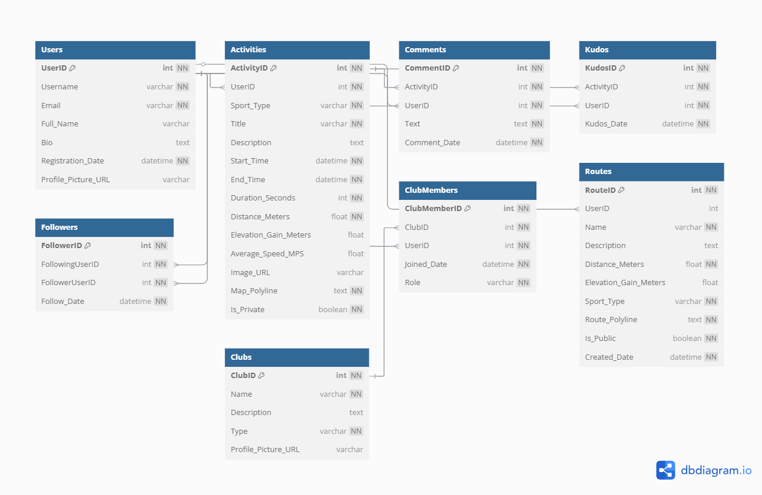

## **Conclusion**

This project explored the design of **Strava's data structure,** specifically its schema and Entity-Relationship diagram. Strava has revolutionized how athletes **track and share their activities,** fostering connections and motivating self-improvement.

The platform's detailed data model, which includes components like **users, activities, segments, clubs, and gear,** is essential for its seamless functionality. By understanding this structure, we can see how Strava effectively manages the complex world of **athletic performance data** and **social interactions**, driving its widespread popularity and continued growth in the digital fitness landscape.